**BASIC COMMANDS**

1. **COPY THE DIRECTORIES:**

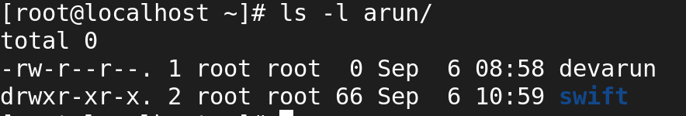

* Copying the directories from source file to destination file using cp command and -r options.

1. **COPY THE FILES:**

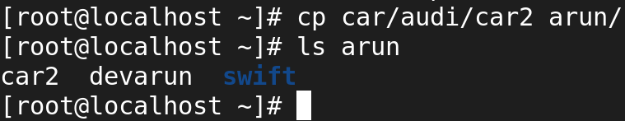

* Copying the Files from source file to destination file using cp command.

1. **MOVING THE DIRECTORIES:**

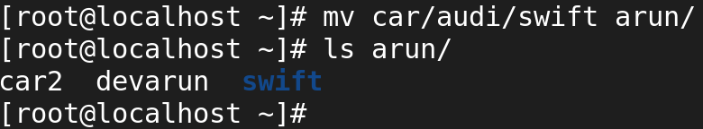

* Moving directories from source file to destination file using mv commands.

1. **MOVING THE FILES:**

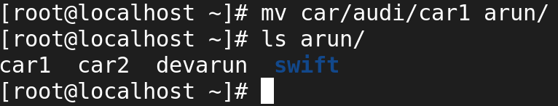

* Moving files from source file to destination file using mv commands.

1. **RENAME THE DIRECTORY NAME:**

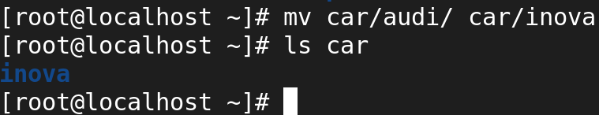

* Rename Directories from source file to destination file using mv commands.

1. **RENAME THE FILE NAME:**

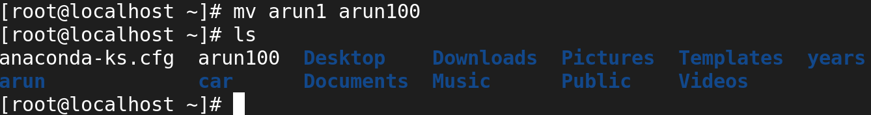

* Rename Files from source file to destination file using mv commands.

1. **ALLOCATING THE SIZE TO THE FILES:**

* **Fallocate -l +1G [Filename]**

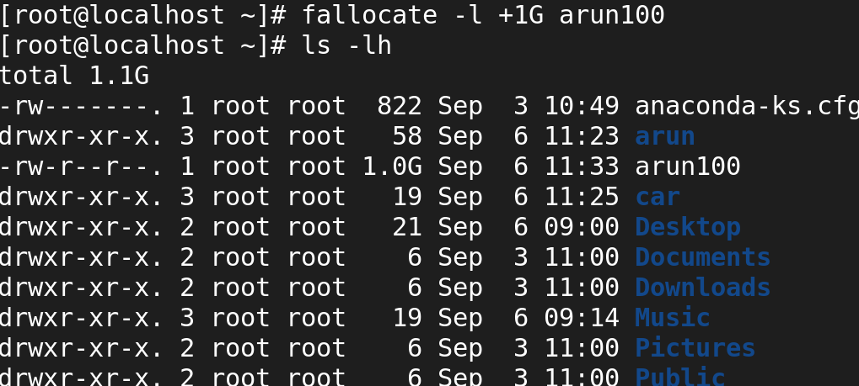

1. **List:**

* **ls:(Long)**

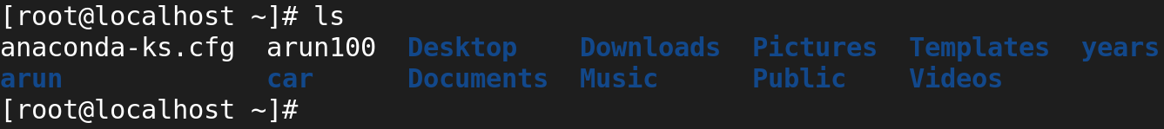

* **ls -l:(Long list)**

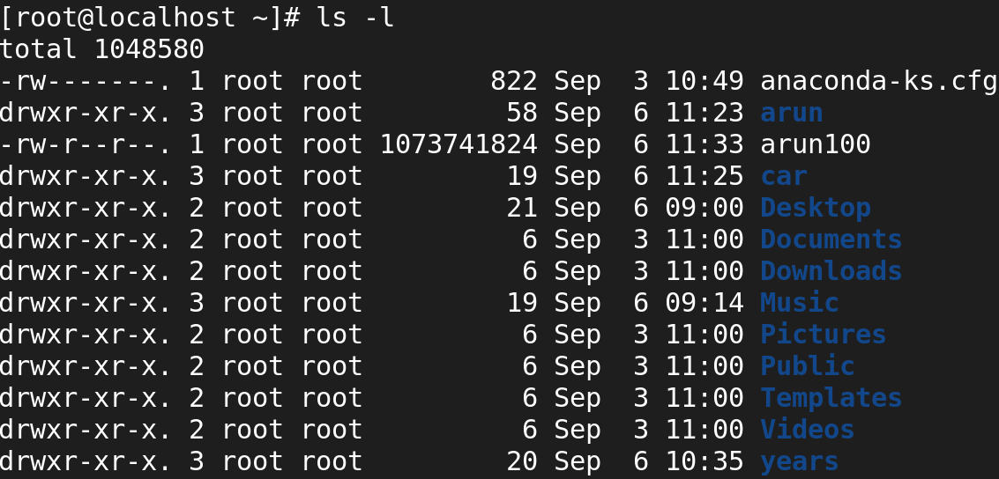

* **ls -ld:(Long list of Particular directories)**



* **ls -la:( Long list of Hidden files)**

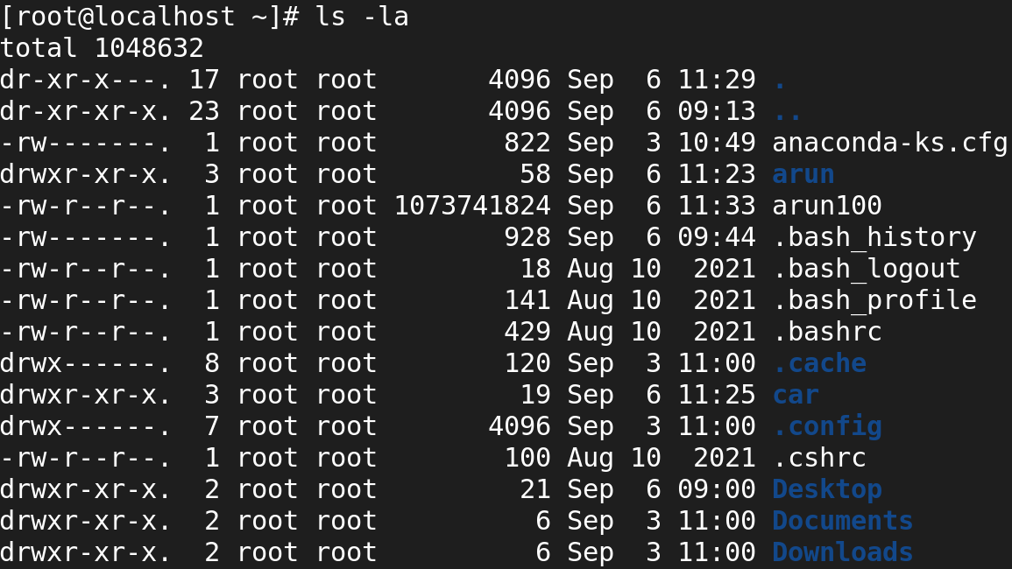

* **ls -lt:(Long list of time)**

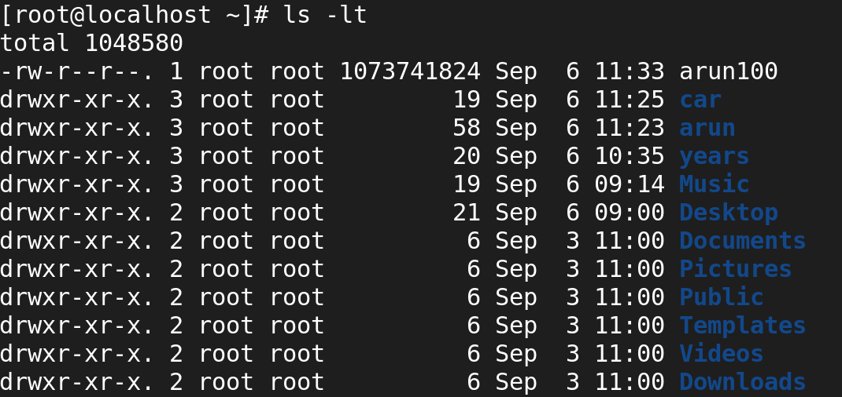

* **ls -ltr:(Long list of time reverse)**

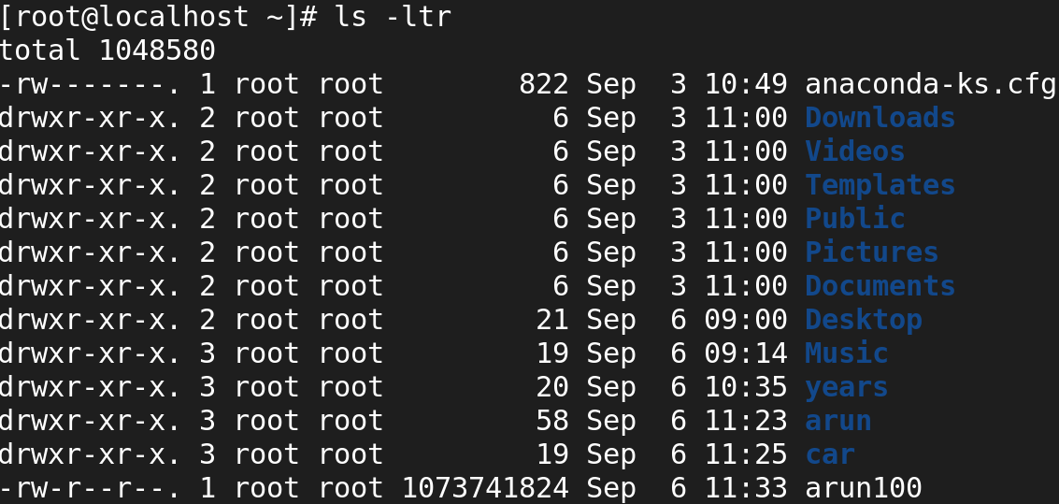

* **ls -li:(Long list of I node number)**

